AES Motion Correction App Manual

# Introduction

The motion correction app can be used to automatically correct for rigid XY motion in the sample after imaging with AES. While processing, it can also collect traces for sample ROIs, collect a total (electrical) background mean/stdev trace, collect an x-y displacement trace, check for sample ROIs drifting outside of the AES activation region, save a time projection of the video, and compress the video by eliminating data from outside the AES excitation region.

The typical approach to motion correction by cross correlation fails with AES because the pattern of exposure generated by AES does not shift with the sample while also dominating the cross correlation. This can be corrected using our a priori knowledge of the exposure pattern, by subtracting the local mean intensity from regions where the laser was on and setting all other pixels to 0.

# Installation

The program is written using MATLAB app designer. It can be run either using the source code within the app designer interface, installed as a MATLAB app to run within MATLAB, or installed as a standalone app alongside the MATLAB 2023b Runtime. All code was tested with Windows 10 and Windows 11 and MATLAB versions 2022a and 2023b. Additionally, the code requires the *Signal Processing* and *Image Processing* Toolboxes.

Due to the use of the LibTiff library integrated into MATLAB for accessing Tiff stacks, versions of MATLAB prior to 9.14 (2023a) are unable to read Tiff stacks with more than 2^16 frames. The code will truncate all data to 64000 frames if using prior releases.

# Input

Input consists of one or more videos to be processed and a series of masks delineating regions of laser exposure and features of interest on the sample.

## Video

The video must be formatted as a 16-bit pixel depth Tiff stack. If multiple channels are used, they must be interlaced throughout the video. The “Main Channel” is the channel used for motion registration.

### Multiple Videos

If several videos were taken of the same region with the same exposure patterns, the same segmentation can be applied across multiple videos. If the sample shifts between recordings, the code will automatically adjust the displacement so that any sample ROI’s return to their locations at the beginning of the first video in the list.

### Bidirectional Slow Axis Scanning

This software was designed to work with output from a custom version of Scan Image which allows for slow axis scanning. As a quirk of the process, each image in the stack consists of 2 frames, the first in the top half while the second is reflected vertically in the bottom half. Small electrical delays in the system caused the two adjacent frames to be offset in opposite directions. Enable the bidirectional option tells the software to apply the reverse delay and split each frame into two frames to reconstruct the video.

## Masks

Binary masks used for processing are grouped into three categories: AES masks, sample masks, and exposure masks. All masks are binary matrices encoded as a Tiff image with the same dimensions as one frame of the video. If the excitation pattern is different for different channels of the video, you will need to load and adjust the masks for each channel separately.

The AES and Exposure masks can also be autogenerated or modified (x-y displacement and dilation) before processing the video using built in tools.

### AES Masks

AES masks correspond to the regions of the frame where the laser is active and which give meaningful structural information. These masks lean towards more restricted regions when boundaries are ambiguous to ensure that the pattern of AES exposure is effectively neutralized before cross correlation. These masks are necessary to do any motion correction with AES.

### Sample Masks

Sample masks correspond to spaces on the sample itself that we are trying to track (i.e., neurons). These are needed only for extracting traces from the data while processing and for determining if the sample ROI drifts outside of the laser exposure region. Otherwise, they can be ignored.

### Exposure Masks

The exposure mask is the total area illuminated in the frame. This is essentially the superposition of the AES masks, but it should be expanded more liberally. The area outside the exposure mask is used for background measurement, so a narrower mask increases the risk of including unintended signal in the trace. This can also be used to reject pixels with crosstalk if different masks are applied to different channels. If processing slow axis bidirectional data, the mask must be twice the height of a frame of the video. If background traces are not being taken during processing, this mask can be ignored.

# Output

## AES File Format

All Trace data is saved in a custom file format for more efficient writing and use of storage space. The format starts with an unsigned 32-bit integer for the number of frames (rows), an unsigned 32 bit integer for the number of values stored per frame (columns), a 32 bit integer denoting the bit depth of each data point, and a binary value denoting whether the data is signed or unsigned. The remainder of the file is the complete matrix in binary format written row by row.

“aes_file_format.txt” contains the complete description of the format while the class definition “AESFile.m” can be used to read from and write to these files.

## Content

The following can be output for each video.

* **Video**: The app can save one video (.tif format) after processing with any of the following
  + **Motion Correction**: After performing rigid lateral displacement registration, the frames of the video are shifted in the opposite direction to correct for motion.
  + **Compression**: Pixels outside of the exposure mask are set to 0 and pack bits compression is applied. As a result, while any information outside of the exposure region is lost, the file size is decreased by a factor of 1/occupancy. Note that opening the full file into ram will still require the uncompressed space (i.e., in Image J).
  + **Background Subtraction**: Subtract the mean value of the pixels outside of the exposure mask from every pixel in the image. This is recommended if compression is applied so that pixel values correspond proportionally to photon counts.
* **Traces:** The app can save traces in the AES file format. Each row in the matrix corresponds to a frame in the video.
  + **BG Mean:** The mean (first column) and standard deviation (second column) of all pixels outside of the exposure mask. (Note that this is the electrical baseline, NOT fluorescence background)
  + **Displacement:** The number of pixels displaced in the x (first column) and y (second column) as calculated by the motion registration.
  + **In Bounds:** Boolean values determining whether each sample ROI lies entirely within the AES masks. 1 indicates in, 0 indicates out. Each column corresponds to one of the sample ROI’s. The **ROI Index** file specifies the mapping between column index and ROI.
  + **Sample:** Each row contains all pixel values from the frame specified by the corresponding sample ROI mask. Values are taken after motion correction (if applicable).
    - **Zeroed:** Indicates the **BG Mean** is subtracted from all pixel values.
  + **AES:** Each row contains all pixel values from the frame specified by the corresponding AES ROI mask. Values are taken before motion correction (if applicable).
    - **Zeroed:** Indicates the **BG Mean** is subtracted from all pixel values.
* **Miscellaneous:** Other files
  + **Masks**: All masks used for processing (sample, AES, and exposure masks). This includes any auto-generated masks and modifications made to masks manually before processing.
  + **ROI Index:** Text file mapping sample ROI names to column indices in the **In Bounds** matrix.
  + **Projection:** Time average (split by channel) of the output video.

## File Structure

<base name> indicates the name of the input video without the “.tif” extension. <channel> indicate a specific channel number. **Bolded** text indicates one of the files mentioned above in the “Type” subsection. Otherwise, quotation marks indicate the literal name of the folder.

* Output folder
  + Mask Folder “masks”
  + Video Folder <base name>
    - Bin Folder “bin_files”
      * **BG Mean**
      * **Displacement**
      * **In Bounds**
      * **ROI Index**
      * AES Trace Folder “aes_roi_traces”
        + **Sample**
      * Sample Trace Folder “sample_roi_traces”
        + **AES**
    - **Video**
    - **Projection**

If channels have different masks, the mask folder has the following structure, where <aes> is the name of the AES ROI, and <smpl> is the name of the sample ROI.

* Mask Folder “masks”
  + Channel Folder “channel_” <channel>
    - AES folder “AES”
      * <aes>
    - Sample Folder “sample”
      * <smpl>
    - Exposure mask “exp_mask.tif”

Otherwise, if all channels share the same masks, the file structure is:

* Mask Folder “masks”
  + AES folder “AES”
    - <aes>
  + Sample Folder “sample”
    - <smpl>
  + Exposure Mask “exp_mask.tif”

## Naming Conventions

<base name> is the name of the input video, <video name> is the name of the output video, <smpl> is the name of the Sample ROI, <aes> is the name of the AES ROI, and <channel> corresponds to a specific channel.

* **Video**
  + **Motion Correction:** <base name> “_motion_corrected.tif”
  + **Compressed** (and not **Motion Corrected**): <base name> “_compressed.tif”
  + Neither **Motion Corrected** nor **Compressed:** <base name> “_processed.tif”
* **Trace**
  + **BG Mean**
    - **Multiple Channels:** <base name> “_bg_mean_ch” <channel> “.bin”
    - **Single Channel:** <base name> “_bg_mean.bin”
  + **Displacement:** <base name> “_displacement.bin”
  + **In Bounds**
    - **Separate Channel Masks:** <base name> “_in_bounds_ch” <channel> “.bin”
    - **Common Channel Masks:** <base name> “_in_bounds.bin”
  + **Sample**
    - **Multiple Channels**
      * If **Zeroed:** <base name> “_” <smpl> “_zeroed_ch” <channel> “.bin”
      * Otherwise: <base name> “_” <smpl> “_ch” <channel> “.bin”
    - **Single Channel**
      * If **Zeroed:** <base name> “_” <smpl> “_zeroed.bin”
      * Otherwise: <base name> “_” <smpl> “.bin”
  + **AES**
    - **Multiple Channels:**
      * If **Zeroed:** <base name> “_” <aes> “_zeroed_ch” <channel> “.bin”
      * Otherwise: <base name> “_” <aes> “_ch” <channel> “.bin”
    - **Single Channel**
      * If **Zeroed:** <base name> “_” <aes> “_zeroed.bin”
      * Otherwise: <base name> “_” <aes> “.bin”
* **ROI Index:** <base name> “_roi_index.txt”
* **Projection:** <video name> “_projection.tif”

# Motion Correction

Beyond mean subtraction within the AES ROI’s, the application performs several operations to generate reference and comparison frames to better register the current position of the sample. These parameters are used solely to calculate motion registration, meaning that none of these operations are applied to any output data. The optimal parameter set will vary depending on the content of the video.

**Reference Frame** here refers to a processed average of initial frames from the main channel of the reference video used as a ground truth for where the sample should be.

**Comparison Frame** here refers to a processed average of frames near a given time stamp in main channel of the video. The comparison frame is cross correlated with the reference frame to determine the displacement of the sample at a given time stamp.

## Parameters

**Initial Window:** The number of frames from the beginning of the reference video used to generate the reference frame.

**Temporal Smoothing Window:** The comparison frame is formed using a gaussian average (1/e^2 diameter) of consecutive frames in the video to generate a clearer image. Higher SNR allows for a smaller temporal smoothing window and faster motion correction, but an excessively small temporal smoothing window can lead to faulty registration.

**Spatial Blur:** A gaussian blur (1/e^2 radius) is applied to the comparison and reference frames before cross correlation.

**Initial Passes:** Iteratively corrects for motion to generate a clearer reference frame. i.e., the first pass is a simple average of the initial window, the second pass uses the simple average to correct for motion in the initial frames and averages again.

**Correction Passes:** Iteratively corrects for motion across the entire video before outputting data on the final pass. Each subsequent pass uses the displacement data collected from the prior pass to adjust the frames in the temporal smoothing window prior to applying the temporal average to produce a cleaner comparison frame.

**FFT Cross Correlation:** Performs the cross-correlation to calculate displacement as well as any spatial blur using fast Fourier transforms. FFT cross correlation scales favorably to direct cross correlation as the image size increases; however, we limit direct cross correlation calculations to the domain of each individual AES ROI. As a result, FFT cross correlation is often faster for images with larger AES ROI’s; however, direct cross correlation may be faster for smaller ROI’s depending on hardware.

# UI Elements

The remainder of this document is dedicated to covering the UI operations.

1. Viewing Window
2. Channel Select Field
3. AES ROI Panel
4. Sample ROI Panel
5. Stack Tab
   1. Load Reference Stack
   2. Bidirectional Shift
   3. Window/Level
   4. Manage Input Videos
   5. Process Video
6. ROI Tab
   1. Load Exposure Mask
   2. Remove Exposure Mask
   3. Load AES ROIs
   4. Load Sample ROIs
   5. Autodetect ROIs
   6. Adjust ROIs

## 1. Viewing Window

The viewing window lets you look at the masks in relation to your reference image before committing to file processing. ROI’s can be selected by clicking on them. Hold control while clicking to highlight multiple masks. Conversely, selecting an ROI in one of the list panels on the side or in the ROI adjustment window will highlight it in the viewing window.

The reference image is shown in gray scale, AES ROIs are shown in yellow, sample ROIs are shown in red, the exposure mask is shown in blue, and highlighted ROIs are shown in green.

## 2. Channel Select Field

The channel select field allows you to swap between channels of the reference stack for multi-color and/or bidirectional videos. For slow axis bidirectional video, the projection of odd frames is shown on round numbers while the projection of even frames is shown on half numbers (i.e., the even frames of channel 2 correspond to 2.5 on the spinner while the odd frames correspond to 2.0). If using different masks for different channels, you must switch to the desired channel before adding/removing/modifying masks.

## 3. AES ROI Panel

This panel lists all currently loaded AES ROI masks. New masks can be loaded using the add button. The remove button removes all masks currently selected on the list. The rename button renames the currently selected mask. If multiple masks are selected, the first mask in the list is chosen to rename.

## 4. Sample ROI Panel

This panel lists all currently loaded sample ROI masks. New masks can be loaded using the add button. The remove button removes all masks currently selected on the list. The rename button renames the currently selected mask. If multiple masks are selected, the first mask in the list is chosen to rename.

## 5. Stack Tab

### 5.1 Load Reference Stack

Loading a reference stack stores the filename for processing while also reading in an initial average of frames to view alongside masks in the viewing window. It is set not to read more than 5000 frames for initial viewing.

The “Main Channel” is the primary channel that is used for motion correction.

The “frame limit” can be used to speed up loading by using fewer frames. Additionally, if the frame limit is significantly different from the number of frames used to generate the reference for motion correction, the sample ROI segmentation may not be valid.

The “bidirectional” box tells the software that the image was generated with slow axis bidirectional scanning.

“Split Channels” indicates that the different channels are segmented independently and use different masks.

## 5.2 Bidirectional Shift

If slow axis bidirectional scanning is used, a delay between the microscope time software and the scanner will cause a vertical shift between even and odd frames. When the software understands that bidirectional slow axis scanning was used during acquisition, it automatically calculates and applies the reverse shift using cross correlation of the reference images. If this does not yield satisfactory results, the pixel shift can be adjusted manually from a small window opened with the “bidirectional shift” menu option.

### 5.3 Window/Level

After loading a reference image, you can adjust the window level to see features better. This has no impact on how the program processes the video. Different channels are adjusted independently.

### 5.4 Manage Input Videos

If multiple videos were taken of the same region, with the same AES pattern, you can reuse segmentation of one video across multiple videos. To do this, you must input all target videos prior to processing. 5.4 opens a window where you can manage active videos and select which one is shown in the viewer. The current reference stack will always be at the top of the stack list and cannot be removed. You can select a different reference stack by selecting a video from the stack list and clicking “set reference”.

### 5.5 Process Video

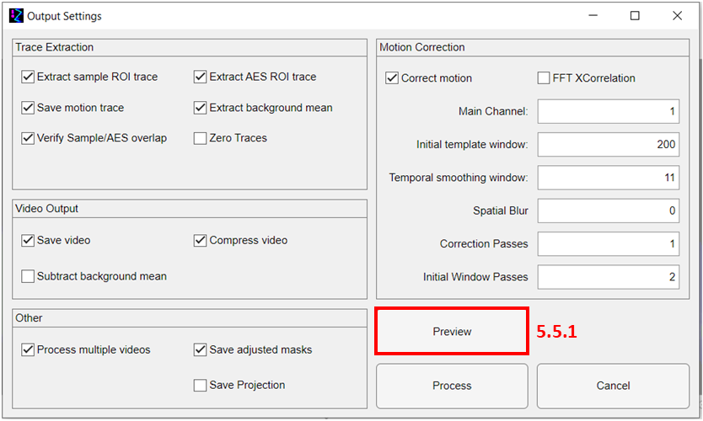

After setting up all ROIs that you intend to use, you can open the output dialog window to configure data extraction and output settings.

**Trace Extraction:** Options for extracting trace data across the video in the AES File format. The Output section provides further details on the extracted data.

**Video Output**: Options for saving an output video. The Output section provides further details on the options for processing the output video.

**Motion Correction**: These tools are only accessible if an AES ROIs are loaded. The Motion Correction section details the various parameters affecting displacement registration.

**Other**:

1. **Process multiple videos** using the same segmentation to process multiple videos simultaneously. (other videos must already be loaded using the 5.4 Video Manager)
2. **Save adjusted masks**. Save all binary masks used to process data as Tiff’s.
3. **Save Projection**. Save the average of all frames of the processed video as a Tiff stack. Each Tiff corresponds to one channel of the video.

**Buttons**:

1. **Preview** opens a preview window to see how the motion correction output will look for a small selection of frames under the current setting. (covered in more depth in 5.5.1)
2. **Process** commits current settings and begins processing videos.
3. **Cancel** exit from window.

### 5.5.1 Preview Window

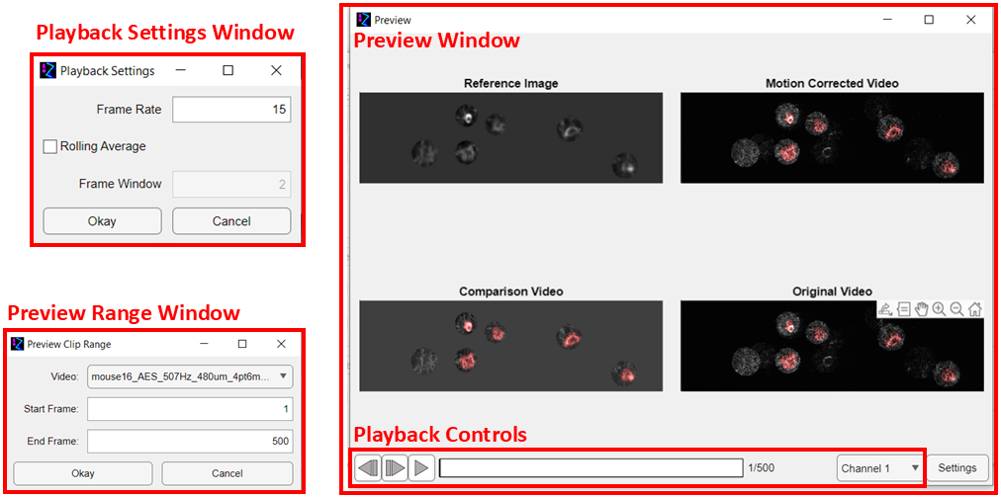

**Preview Range Window**

When “Preview” is selected from the “Process Video” window, another window appears asking for a video (from the list of videos that you have selected for processing) along with a range of frames.

**Preview Window**

The selection of frames requested from the Preview Range Window is generated based on the motion correction settings currently selected. The “Reference Image” is the initial averaged frame generated from the reference stack (regardless of what video is selected). The “Original Video” and “Motion Corrected Video” are the frames before and after motion correction. The “Reference Image” and “Comparison Video” are the reference frame and comparison frames as described in the Motion Correction section. The red regions denote the sample ROI pixels.

**Playback Controls**

Playback controls including play/pause, advance frame, and previous buttons, a scrubber, and a channel selector are available to view the video. The video plays at 30 fps by default.

**Playback Setting Window**

The “Settings” button opens a separate window where you can adjust the frame rate of playback and apply a rolling average to the original and motion corrected videos.

## 6. ROI Tab

### 6.1 Load Exposure Mask

Select a tiff to serve as the exposure mask. The image should have the same dimensions as the reference stack with value 1 inside the mask and 0 outside the mask. For slow axis bidirectional data, the mask should be twice the size of the image on the y axis, with only the top half being used for the mask.

### 3.2 Load AES ROIs

This is the same as clicking the “add” button in the AES ROI Panel. Like the exposure mask, each AES mask should be a separate Tiff file with the same dimensions as the reference stack, having value 1 within the mask and 0 outside.

### 3.3 Load Sample ROIs

This is the same as 3.2 but for the sample masks.

### 3.4 Autodetect ROIs

A window opens to select thresholds for generation of the AES and exposure masks. Disabling either of the sliders will disable the generation of the respective masks. For the exposure mask, all pixels below the selected value (shown in green) are selected as the mask. For the AES masks, all pixels below the selected value (shown in red) are segmented with a blob detection algorithm.

### 3.5 Adjust ROIs

You can use the adjustment window to fine tune existing masks. You can either laterally shift them or change the margin to expand/contract the masks. Individual masks can be selected by either clicking on them in the viewing window or selecting the name from the drop-down menu. The drop-down menu also allows you to select the exposure mask or simultaneously select all AES/Sample masks. “Cancel” reverts all masks to before the window was opened while “apply” commits the changes.